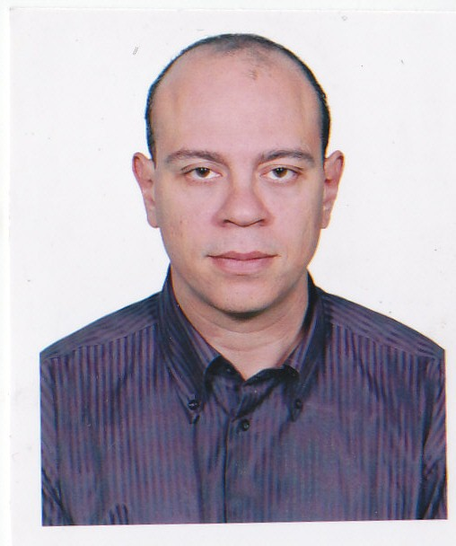

Ayman Mahmoud Ali

CURRICULUM VITAE

Construction Manager
(Civil ,Fit-Out , Leed and Mega projects)

Address: |  | 2 Moubark st. Haram Giza-Egypt (Permanent)
Contacts: |  | +966562226761 Saudi Arabia (Current)
E-Mails: |  | aymangamrawi@gmail.com (Personal)
Skype: |  | ayman2100_2100

PERSONAL DATA :

Resides in (Current): | Makkah - Sauid Arabia
Birth Date: | Sep. 24,1977
Citizenship: | Egyptian
Languages: | English, Arabic
EDUCATION :

Education Level: | MBA (25% accomplish )- Project Managment | University : | Anglia Ruskin University -UK
Education Level: | Bachelors 5 yr Degree | University : | Cairo university - Egypt
Department: | Civil Engineering | Grade: | Good
Graduation Year: | 2000 | Industry Experience: | 13 years
COURSES & TRAINING :
Course/Workshop Description |  | Provider

PMP : NEW Horizon -Qatar.

Estidama Abu Dhabi Urban Planning Council

FIDIC ACC Training center

OSHAS180001 ACC Training center

ISO 9001 ACC Training center

CAREER SUMMARY / OBJECTIVE:

A highly qualified professional with excellent knowledge and 14 years of Extensive International experience in Construction Industry mainly in constraction and management at Egypt, Qatar and UAE , Saudi Arabia with some of the world's renowned multinational organizations. Proven expertise in driving efficiency and productivity through evaluation of cost management systems. Talent and self motivated. Have High ability for accomplishing target plan. Work with a major international consult Like EC Harris & Handel
http://www.echarris.com
http://handelarchitects.com

AREA OF EXPERTIESE:

Industry Sector | Expertise | Experience
Management/Support | Project Management | 8 years
Engineer – General | Project Management | 5 years

TECHNICAL SKILLS:

  - Work as a project manager.
  - Work at Mega projects
  - Ability for complex projects.
  - Familiar with ISO 9001 & ISO 14001 &OHSAS 18001.
  - Key Management Skills.
  - Management of site based supervision team on a large-scale fast-track project
  - PMP Course.
  - Pro-active and results driven personality, able to operate with large degree of independence
  - Follow up more than 30000 activities
  - leading and managing multi-national teams “ no problem with cross culture “.
  - Preparing breakdown analysis for activities.
  - Have an experience In Preparing Schedule Planning.
  - Involved in project management processes namely initiation, planning, execution, monitoring & controlling and close out.
  - Monitor and administrate Sub contractors
  - Responsible for preparing preliminary hand over reports
  - Responsible for review of all claims and EOTs
  - Managers all variations and changes from a company perspective
  - Monitor daily activities and try to improve
  - Monitor cost and try to be under budget
  - Monitor manpower histogram and check production VS manpower
  - Ability to create/update cost estimation, tracking and control methods and procedure and continuously look at the ways of improving processes and revise procedure accordingly to reflect the latest engineering and project execution philosophies.
  - Implementation of Earned value analysis every milestone.
  - Planning and development of cost and schedule management system.
  - List Method Statement and check avability and continously to match site conditions
  - Study project access and mobilization (layout site plan – tower crane location equipment histogram)
  - Creative solutions for site conditions
  - Knowledge of computer based Managmenting and Planning tools, Excel, Access, MS Office, MS Project or equivalent packages and ability to apply cost analysis techniques.
  - Project control management
  - Identification of problematic areas and recommending corrective measures.
  - Snagging , testing and commisioning
  - Responsible for the project handover and final walk through
  - Ability to take effective solutios
  - Seasoned in High Rise Buildings, , Five Stars Hotels, Residential complexes etc .
  - Work in many Projects in the Field of Preparing the Steel RFT Shop Drawing and bending lists.
  - Preparation of Structural & Architectural BOQs.

PERSONAL SKILLS:

*Demonstrated Ability to work in a multinational diverse environment.
* Demonstrated ability to effectively communicate, both orally and in writing.
*Able to effectively interface with various functions
* Strong leadership skills and Good Negotiator.
* Ambitious, sincere and devoted.
* Strong follow up skills and Ability to meet deadlines and good time management skills.
*Robust ,Hard Worker and accurate.

EMPLOYMENT HISTORY :

Mar. 08- Present
Arabian Construction Company S.A.L. (ACC) www.accsal.com
Position :Construction Manager / acting project manager
1-Project: JODP Phase3 – Makkah- Saudi Arabia ,
Project Brief Description: Hilton Makkah + JODP Mall “140,000 square meter “ is a MEGA project contain 4 towers and big pudiom mall including RETAIL and COMMERCIAL .
Project Client and Basis:
*The Client is JODP Real Estate Investment Company
*Contract is on US$ 800 Million cost value .
2-Project: Rosewood Hotel – Abu Dhabi- UAE , http://www.rwabudhabi.com/
Project Brief Description: Rosewood Abu Dhabi is an unrivaled five star hotel and residences..
Project Client and Basis:
*The Client is Mubaldla Real Estate Investment Company http://mubadala.ae/.
*Contract is on US$ 350 Million cost value .
3-Project: Parcel 14-PEARL Qatar- Qatar , http://www.rwabudhabi.com/
Project Brief Description: Parcel 14 one of Fully Integrated Luxury Residence Community at Pearl qatar www.thepearlqatar.com
Project Client and Basis:
*The Client is UDC.
*Contract is on cost plus basis with an estimated cost value of US$ 250 Million.

Responsibilities:
Study project access- Project Mobilization (prepare site layout plan – position of tower crane –prepare equipment histogram according preliminaries)- List Method Statement according project WBS - Check ITP plan- key management skills - Management and data analysis & Decision maker & Design groups according tasks & Continuously plan & applaying succession planing & Creative solution & Check with engineering department & Improve method statement to comply with project conditions and availability of manpower & Cost estimate & Develop the skills of team work and work on the composition of the second row & Manage and Monitor sub-contractor and evaluate their performance & MEP service work & Check quantities and material supplier & keep an eye on punch list and any item will effect handing over such as civil defense and municipality requirement and Final report to project manager.

Apr. 03 - Feb 08
ASCO for CONTRACTING W.L.L. - Egypt
Position :Construction Manager (Jan. 06 – Feb. 08)
Position :Section Engineer (Apr. 03 – Jan 06)
Projects ( 700 Million LE) :
- Factory : Andalous Factory for medicine .
- Commercial:Mall in new Cairo
- Technical :STUDIO INTERACTIVE
- Recidance :compound 150 villas
Responsibilities:
Study and analyze project specification and drawings
Define Construction requirements and acceptance criteria
Prepare list of required Method Statement and agree with Construction Manager
Plan, monitor and control execution of work on site and verify compliance with: approval shopdrawing ,Specification, Constructionschedule, Approved Method Statements, Resolve any technical related issues.
Overall, supervision and coordination of General Foreman and Site Engineers areas of responsibilities and allocation of work areas.
Perform comparison exercise between the activities as built survey lines, levels (Report by the Site Engineer), and designed as per approved shop-drawings to determine variations and impact on subsequent finishes
Coordinate with Materials Engineer for materials delivery
Proper usage of materials to minimize wastage, allocation of materials in the appropriate
working areas and supervision of materials storage area.
Ensure proper tools/ plant / equipment used by the Construction crew on site.
Supervision and implementation of Safety precautions and take necessary actions to prevent accidents.
Preparing Submittals, Materials Procurement, Preparing sub-contractor invoices, Preparing Client Valuation, Breakdown analyses for prices.
Preparing Contracts, Preparing sub-contractor invoices, Preparing Client Valuation, Technical negotiation with the Suppliers.
Preparing steel R.F.T shop drawings & the bending lists, Execute all concrete works, execute All Fit-out works.
Execute all concrete works, execute All Finishing works, and execute All Steel Structural Works.

Jun. 00 - Mar 03
THE ARABIAN INTERNATIONAL COMPANY W.L.L. - Egypt
Position :Site Engineer (Jun. 00 – Mar. 03)
Projects (500 Million LE ) :
- Military : CORROSION CONTROL FACILITY FACTORY for US ARMY COPS OF ENGINEERS.
- Admministration: Construct New Building of Ministry of interior affair And Repair of another Building.

Responsibilities:
- Execute all Special concrete works (Repair), Preparing steel R.F.T shop drawings & execute All Finishing works
- Execute all Special concrete works (Lifting Form), Preparing steel R.F.T shop drawings .
- Prepare concrete dimension, steel reinforcement shop drawings and bending list.
- Make R.C design for simple structure elements.
- Follow up the work progress at site.
- Coordinating between architecture, civil & MEP works.
- Preparing daily and weekly reports.
- Preparing of Method Statement for all work activities.
- Preparing of all inspection requests for all executed works
- Execute all sub-Structure works (Excavation, piling, concrete foundation).
- Execute all super- Structure works (Slabs, columns, beams).
- Execute all finishing works .

REFERENCES :

All the References are available upon request.

